Requirements Engineering Report for a Computer-Based Library Management System

Dinesh Devkota
Modern Institute of Technology (MIT)
CSE220: Principles Of Software Engineering
Professor Poshan Karki
July 10, 2026

Introduction
Dinesh Public Library is an urban, single branch, community library located in a mixed residential and student population in an urban area, established in 1985. The library has 1 head librarian, 4 subject librarians, 3 circulation/library assistants and 2 part-time administrative/IT support staff (total 10) and between 120 and 160 check-ins of visitors per day, with a high number of check-ins on weekday afternoons and on Saturday mornings. The library has never had an integrated information system for member registration, book cataloging, checkout and return, fine collection and reservation tracking. The library has never used any kind of integrated information system for member registration, book cataloging, checkout/return, fine collection, and tracking reservations.
The purpose of this report is to trace the requirements engineering process carried out in the design of a computer-based Library Management System (LMS) that will replace the manual operations in the library. Requirements Engineering is the disciplined method of obtaining, studying, discussing and specifying the requirements of the stakeholders to ensure that a proposed system satisfies those requirements and meets their problems (Sommerville, 2016). In line with this method, the study uses various elicitation methods such as interviews & questionnaires, direct observation, document study, and a brainstorming session with the stakeholders to create a realistic and comprehensive understanding of the library's operational requirements prior to the commencement of design work.
- Organization Profile
Attribute | Detail
Organization name | Riverside Public Library
Type | Single-branch community / public library
Staff size | 1 head librarian, 4 librarians, 3 assistants, 2 admin/IT (10 total)
Daily visitor volume | 120–160 check-ins per day
Current system | Fully manual: card catalog, paper checkout cards, ledger for fines
Location | Single branch, urban area
Established | 1992: no IT system implemented to date
Problem Statement
This has led to a number of inefficiencies in library operations, as well as a potential risk of losing records with the growth of collections and membership. The following summarizes the heart of the problems found before and during requirements gathering.
- Availability checks are slow and unreliable with book records on handwritten catalog cards and paper checkout slips that are placed in book pockets.
- A patron cannot determine if a book is available, without having to come onto the shelf or request staff to locate it in the card catalog.
- Overdue fines are done by hand from the checkout ledger, and there is often an arithmetic error or dispute with the patron.
- There is no automatic notification of book availability for popular books, and no handwritten waiting list is maintained.
- About 40% of the time administrative and circulation personnel spend on their work is spent on paperwork instead of patron service time.
- Average patron wait time at the circulation desk is 15 minutes during peak hours, mainly due to manual searches of cards and fine calculation.
- There is a high risk of data loss from paper records: There are no backup copies of the catalog nor records of members.
Patron satisfaction is impacted (e.g., wasted trips to find unavailable books, fines that are disputed), staff productivity, and the library's capacity to measure and add to its collections as the need arises.
Project Goal and Scope
- Goal
The purpose of this project is to design a computer-based Library Management System (LMS) for the library that can automate processes such as member registration, book cataloging, checkout/return and computation of fines, and also reduce the amount of administrative work by an estimated 50% while decreasing the average wait time in the circulation-desk by an approximate 40% for patrons searching for books online via an Online Public Access Catalog (OPAC).
- Scope
In Scope | Out of Scope (Phase 2 / future work)
Member registration and profile management | E-book / digital lending platform
Book cataloging and keyword/ISBN search | Inter-library loan integration
Checkout and return processing | Mobile application
Automated fine calculation and payment logging | Self-checkout kiosks
Book reservation (holds) with notifications
Staff login with role-based access control
Requirements Gathering Methodology
A combination of five complementary elicitation techniques was employed, consistent with engineering best practice, as there is no single elicitation technique that is capable of uncovering all stakeholders' needs reliably (Kotonya & Sommerville, 1998; Wiegers & Beatty, 2013). The more than one technique provided an opportunity to validate the results of one technique with another, leading to a higher degree of confidence in the resulting requirement set. This section will describe each of the techniques planned and executed, and the data collected will be analysed in Section 5.
Technique | Purpose | Participants / Data Source
Interviews | Gain detailed qualitative information about the library workflow and daily operational issues. | Head Librarian, Circulation Assistant, IT Support Staff
Questionnaires | Collect quantitative and general information from a sample of library patrons and staff. | Library Staff (n = 10), Patrons (n = 40)
Observation (Books Returned After Checkout) | Record the actual steps involved in the book return process after checkout. | Circulation Desk Operations, observed over 3 days including weekend sessions
Document Analysis | Analyze existing paper forms, ledgers, and records to identify data fields for digital conversion. | Library Card Forms, Checkout Ledger, Fine Ledger, Reservation List
Brainstorming Session | Generate, discuss, and prioritize candidate features for the new library management system. | Cross-functional Team: 2 Librarians, 2 Library Assistants, 1 IT Support Staff
- Interviews
Three key stakeholders were selected to represent management, circulation and technical support and interviewed for 30-40 minutes each using a semi-structured interview. Interviews were based on a short set of open-ended questions, with follow-up questions to explore any of the processes the interviewee rushed through.
- Questionnaires
A structured questionnaire was created and given to both staff and patrons in a printed format and an equivalent Google Forms link to gather responses in person (library hours) and remotely. Small number of open-ended questions were mixed with 5-point Likert-scales.
- Direct Observation
The analyst spent 3 weekday afternoons observing circulation-desk operations without interrupting, engaging in a simple time stamped log of observations (time/actor/action/note). This technique reveals details of the workflow that the interviewees are not aware of and is employed specifically to substantiate or question the claims of interviews and questionnaires.
- Document Analysis
The existing paper artifacts were gathered and analyzed to see which data fields are currently recorded and that none of the fields are lost when transitioning to a digital system. The documents reviewed were Library card registration form, checkout ledger, fine ledger, and handwritten reserved book list.
- Brainstorming Session
A cross-functional workshop with two librarians, two library assistants and one IT support staff was conducted for two hours, to brainstorm and rank candidate features with Moscow prioritization (Must have / Should have / Could have / Won't have this phase).
Findings and Analysis
In this section, the data gathered by each technique in Section 4 is presented and interpreted. If possible, a finding from one technique is cross referenced to another to demonstrate that the findings from both techniques helped to confirm the result.
- Interview Findings
Stakeholder | Key finding
Head librarian | Needs an instant way to check whether any copy of a title is available; currently loses several minutes per request searching the card catalog.
Circulation assistant | Fine-calculation disputes occur roughly 3–4 times per week because the ledger arithmetic is done by hand and totals are sometimes miscopied.
IT support staff | There is no backup of any kind — a fire or flood in the storage room would permanently destroy the entire catalog and membership record.
- Questionnaire Results
Question theme | Result summary
Confidence in record accuracy (staff, avg. score) | 2.3 / 5 — low confidence, frequent misfiled or duplicate cards
Fine-calculation errors per week (staff-reported) | Average of 4–5 errors per week across all circulation staff
Most time-consuming task (staff) | 52% selected 'catalog search'; 31% selected 'fine calculation'
Average reported patron wait time | 14 minutes (consistent with the 15-minute figure from observation)
Willingness to use an online catalog (patrons) | 78% responded 'Yes'
- Observation Findings
The circulation assistant's interview claims were confirmed and refined by direct observations of the fine-calculation errors to be traced to when staff add up the per day late charges in the ledger under time pressure when a queue is waiting. This process is done in front of the patron, so it is prone to disputes and slows down the queue as well. The average time patrons spent in front of a patron service desk, from the moment they approached the desk until they finished checkout was 15 minutes, which was very close to the results of the questionnaire (14 minutes) and the document-derived estimate, which was the same from three totally different sources.
- Document Analysis Findings
The data fields currently recorded on paper were examined on the library card registration form, the checkout ledger, the fine ledger, and the reservation list to create a master list of data fields. The following list, member name, address, contact details, book title, author, ISBN, checkout date, due date, return date, and fine amount are the starting point for the catalog and registration functional requirements in Section 7. The interviews and observation were successful in not identifying any additional data fields beyond those contained in these four documents, thus providing confidence that the digital data model in Section 7 is complete.
- Brainstorming Outcomes
The workshop resulted in a prioritized feature list in the following format, based on a MoSCoW categorization (Table 2), which was the main input into separating the in-scope (Table 2) from the Phase 2 features, as well as the priority column in Table 8.
Priority | Features proposed by staff
Must have | Member registration, catalog search, checkout/return, fine calculation, role-based login
Should have | Automated due-date reminders, reservation/holds with notification, audit logging
Could have | Usage/fine reports, SMS notifications
Won't have (this phase) | E-book lending, inter-library loan integration, mobile app, self-checkout kiosk
System Models
Based on the above collected requirements, three system models were created: a context diagram that depicts the boundary of LMS with the external actors and how they interact with it, an use case diagram that depicts the actors and their use of the system and a workflow diagram comparing the present situation (where the checkout process is done manually) with the proposed situation (where the checkout process is done with the support of the system). The three diagrams are specifically drawn in this study according to the findings in Section 5.
- Context Diagram (Level 0 Data Flow Diagram)
In Figure 1
- Use Case Diagram
In Figure 2
- Current vs. Proposed Workflow
In Figure 3
Functional Requirements
The functional requirements are what the LMS “must” do. These have been taken directly from the results of the interview, questionnaire, observation, and document analysis data in Section 5 and are presented in modules. Each requirement is documented and traced back to the source of its elicitation, as shown in Appendix D, Table D2, from each requirement back to its elicitation source.
ID | Functional Requirement | Priority
FR-01 | The system shall enable circulation of staff to register new members by capturing their name, address, contact details, and identification information. | Must
FR-02 | The system shall enable staff or patrons to search the catalog by title, author, or ISBN within three seconds. | Must
FR-03 | The system shall display the real-time availability of all copies of a book title. | Must
FR-04 | The system shall prevent a book copy from being checked out if it is already on loan. | Must
FR-05 | The system shall automatically remind patrons of a book's due date two days before it is due. | Should
FR-06 | The system shall allow patrons to place a reservation on a book that is currently checked out. | Should
FR-07 | The system shall automatically notify patrons when a reserved book becomes available. | Should
FR-08 | The system shall automatically calculate overdue fines by multiplying the number of late days by a configurable daily fine rate. | Must
FR-09 | The system shall record fine payments and maintain a running total of fines for each member. | Must
FR-10 | The system shall allow librarians to add, edit, and remove catalog information, including title, author, ISBN, category, and number of copies. | Must
FR-11 | The system shall implement role-based access control so that circulation of staff, librarians, and administrators can perform only the actions permitted for their roles. | Must
FR-12 | The system shall maintain an audit trail by recording all system modifications with a timestamp and user ID. | Should
FR-13 | The system shall allow administrative staff to generate daily and weekly reports on circulation volume, overdue items, and fine collection. | Could

Non-Functional Requirements
Non-functional requirements are requirements that specify quality attributes and constraints that are required to be met by the LMS. These were drawn mainly from the expectation of staff and patron as expressed in interviews and questionnaires and are indicative of the level of tolerance of downtime and loss of data found in the library setting (IEEE Computer Society, 1998).
Category | Non-Functional Requirement
Performance | The system shall return catalog search results within 3 seconds and complete book availability checks within 2 seconds, helping reduce the average checkout waiting time from 15 minutes to less than 9 minutes.
Usability | The system shall provide a user-friendly interface that can be learned by non-technical staff (aged 25–55 years) within 2 hours of training.
Security | The system shall use individual staff credentials with role-based access control, and all member data shall be encrypted both at rest and in transit.
Reliability / Availability | The system shall be available during library operating hours (9:00 AM – 8:00 PM, 6 days per week) and maintain a minimum of 99.5% uptime.
Data Integrity & Backup | The system shall automatically back up catalog and membership data at least once every hour, reducing the risk of data loss from paper-based records.
Scalability | The system shall support at least 15,000 catalog titles and 160 daily transactions without performance degradation, while allowing room for future growth.
Compliance | The system shall comply with applicable data privacy regulations governing the storage and use of patron personal information.
Maintainability | The system shall use a modular architecture (e.g., registration, catalog, circulation, and fines as separate modules) to allow future features such as e-book lending and inter-library loans without redesigning the core system.
Current System Limitations
When the manual system is analyzed, cross-validated with all five of the elicitation techniques, the following structural deficits are identified that are precisely what the computer-based LMS is designed to fix.
- No single source of truth: catalog information is not seen together on shelf cards, ledger at checkout, or in the list of catalog reservations, and there is no cross linking.
- No checkout validation, which can mean a book is checked out to two patrons at a time and is not discovered until a return is attempted.
- No audit trail - cannot trace who last recorded changes to a catalog card or ledger entry, or when.
- No backup or disaster recovery of paper records, an unmitigated data-loss risk (e.g., fire, flood, misfiling).
- Retrieval is labor intensive: It may take a few minutes to confirm whether a particular title is 'on' or 'off', which is a factor in the 15-minute average wait time.
- No reporting capability: Management cannot easily review circulation volume, overdue trends or fine revenue to help guide purchasing and staffing decisions.
Proposed System Overview
The overall architecture of the proposed LMS is given as Figure 4, which was agreed by the participants during the brainstorming session (Section 5.5) and was arrived at from the functional requirements in Table 8. Four user groups (circulation, librarians/catalogers, administrator, and patrons at the OPAC or a self-service kiosk) use four basic modules (member registration, catalog & search, circulation, and fines & reservations), all of which are accessed through a single application server that provides role-based access control (FR-11) and that all write to a shared central database, and thereby create no fragmentation as described in Section 9.
Conclusion
A process for requirements engineering (interviews, questionnaires, direct observation, document analysis, brainstorming) was used to elicit a coherent and well-triangulated view of Riverside Public Library's operational requirements. These manual, paper-based methods were determined to be adding measurable costs in staff time (40% of time spent on paperwork), patron time (15 minute average wait), and record integrity (double-loans, disputed fines, no data back-up). The functional and non-functional requirements detailed in Sections 7 and 8 are validated to form the basis for the development of the proposed Library Management System, with the functional requirements directly addressing the library's desired objective of reducing administrative time by 50% and patron wait time by 40%, and have not been given further consideration for the time being due to their lower priority.

Appendix
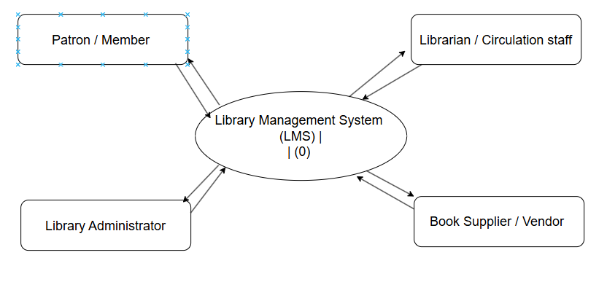
Figure 1
Library Management System - Level 0 Data Flow Diagram
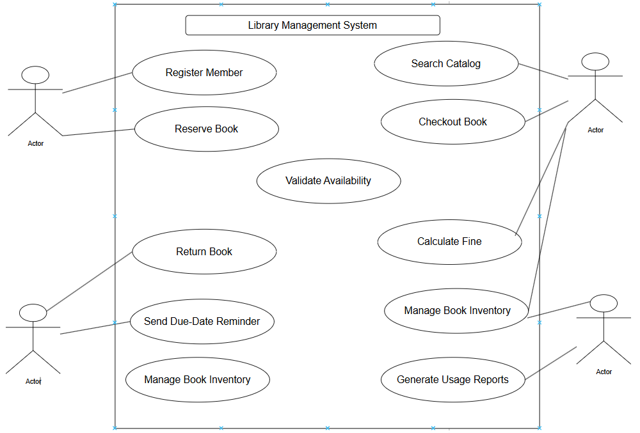
Figure 2
Use Case Diagram
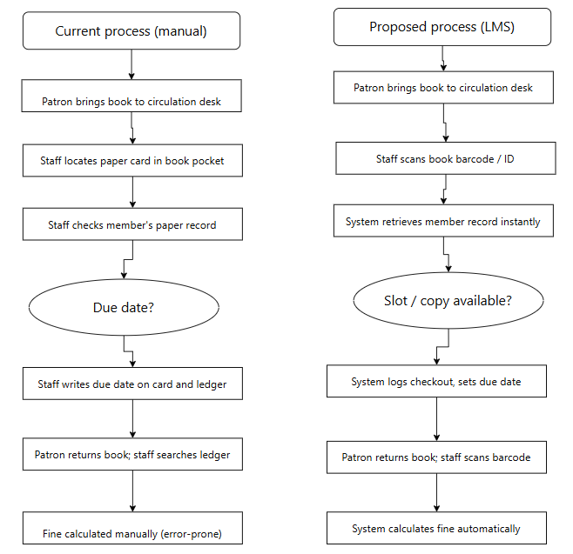
Figure 3
Current vs. Proposed Workflow
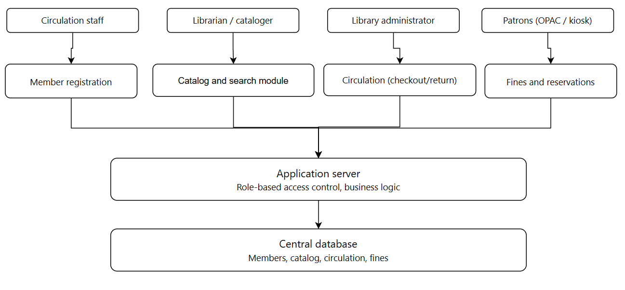
Figure 4
Proposed high-level system architecture for the Library Management System.

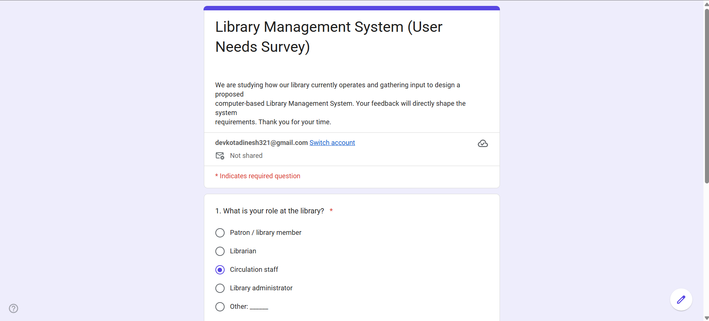
Figure 5
Google form of Library Management System-Survey form
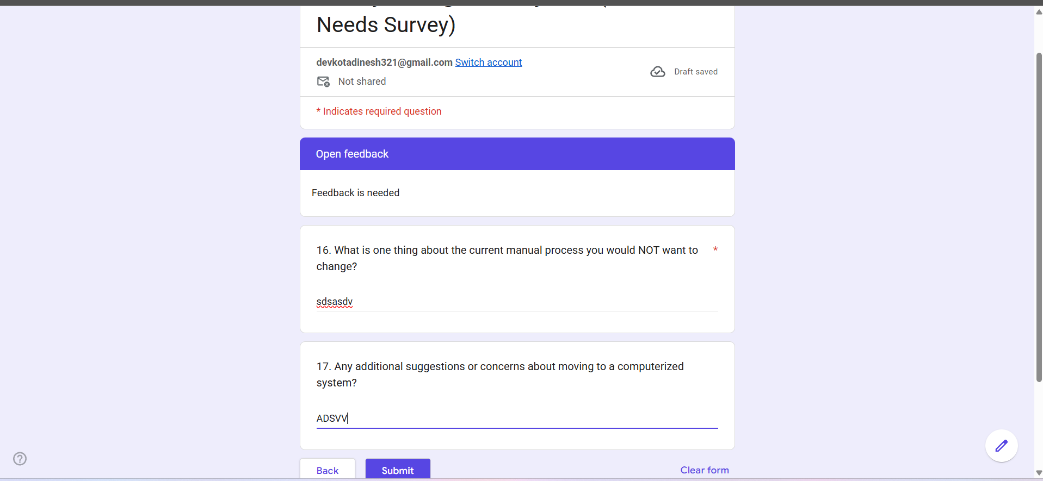
Figure 6
Google form last page where submit is showing
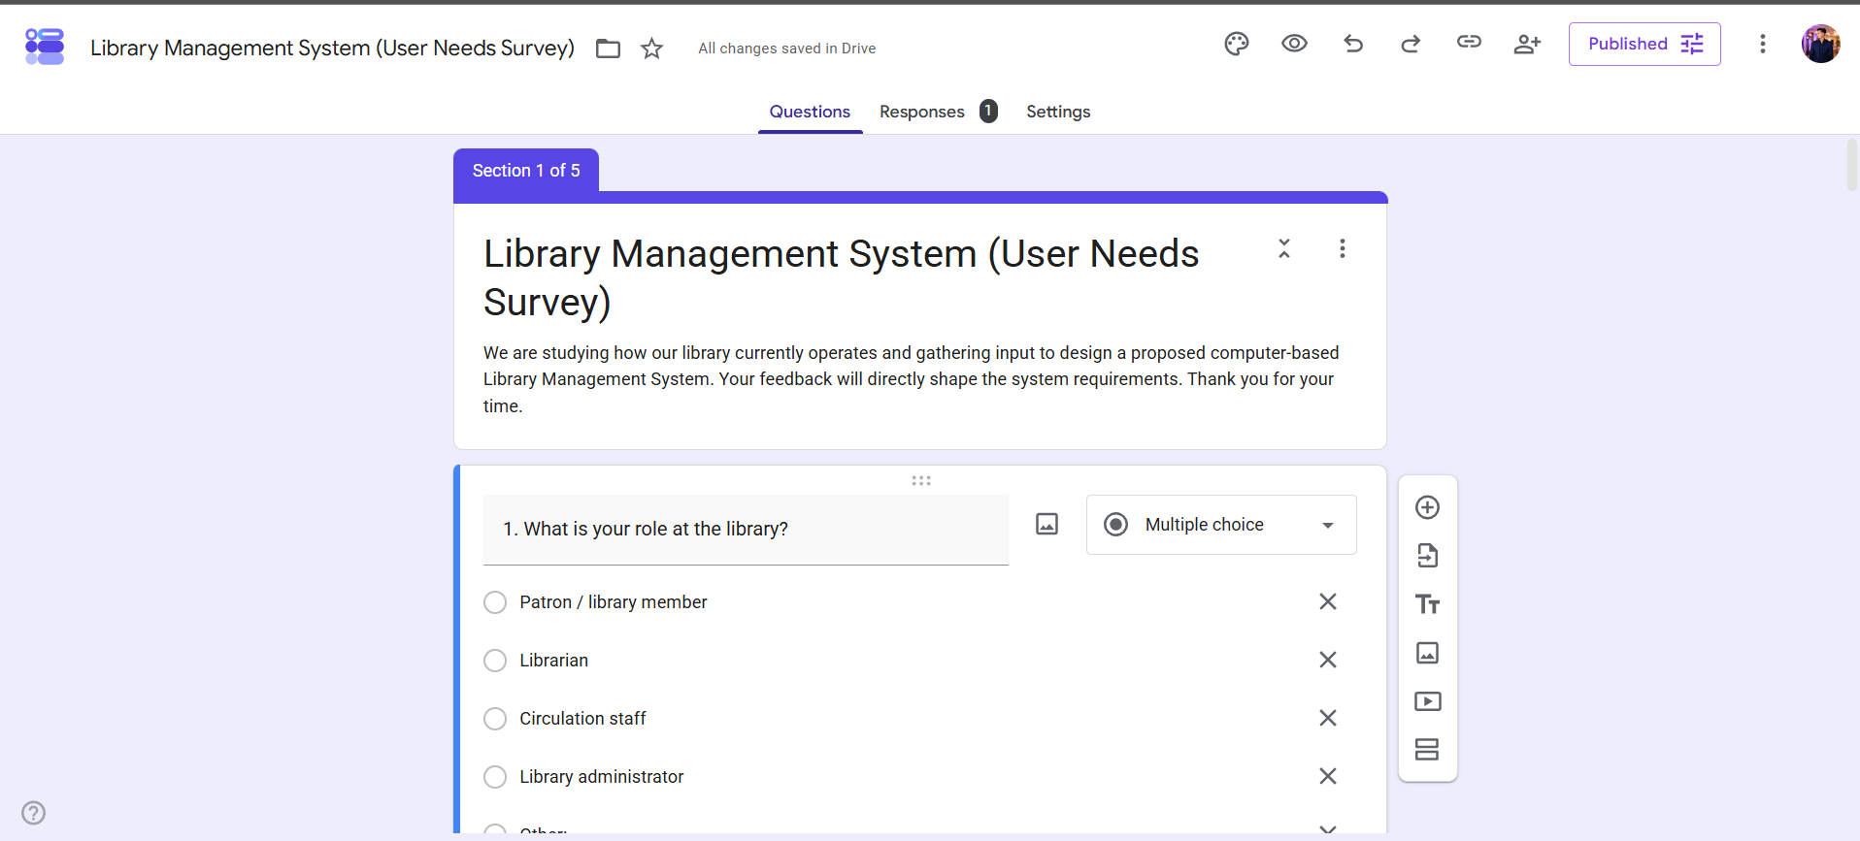
Figure 7
Responses showing filling the form
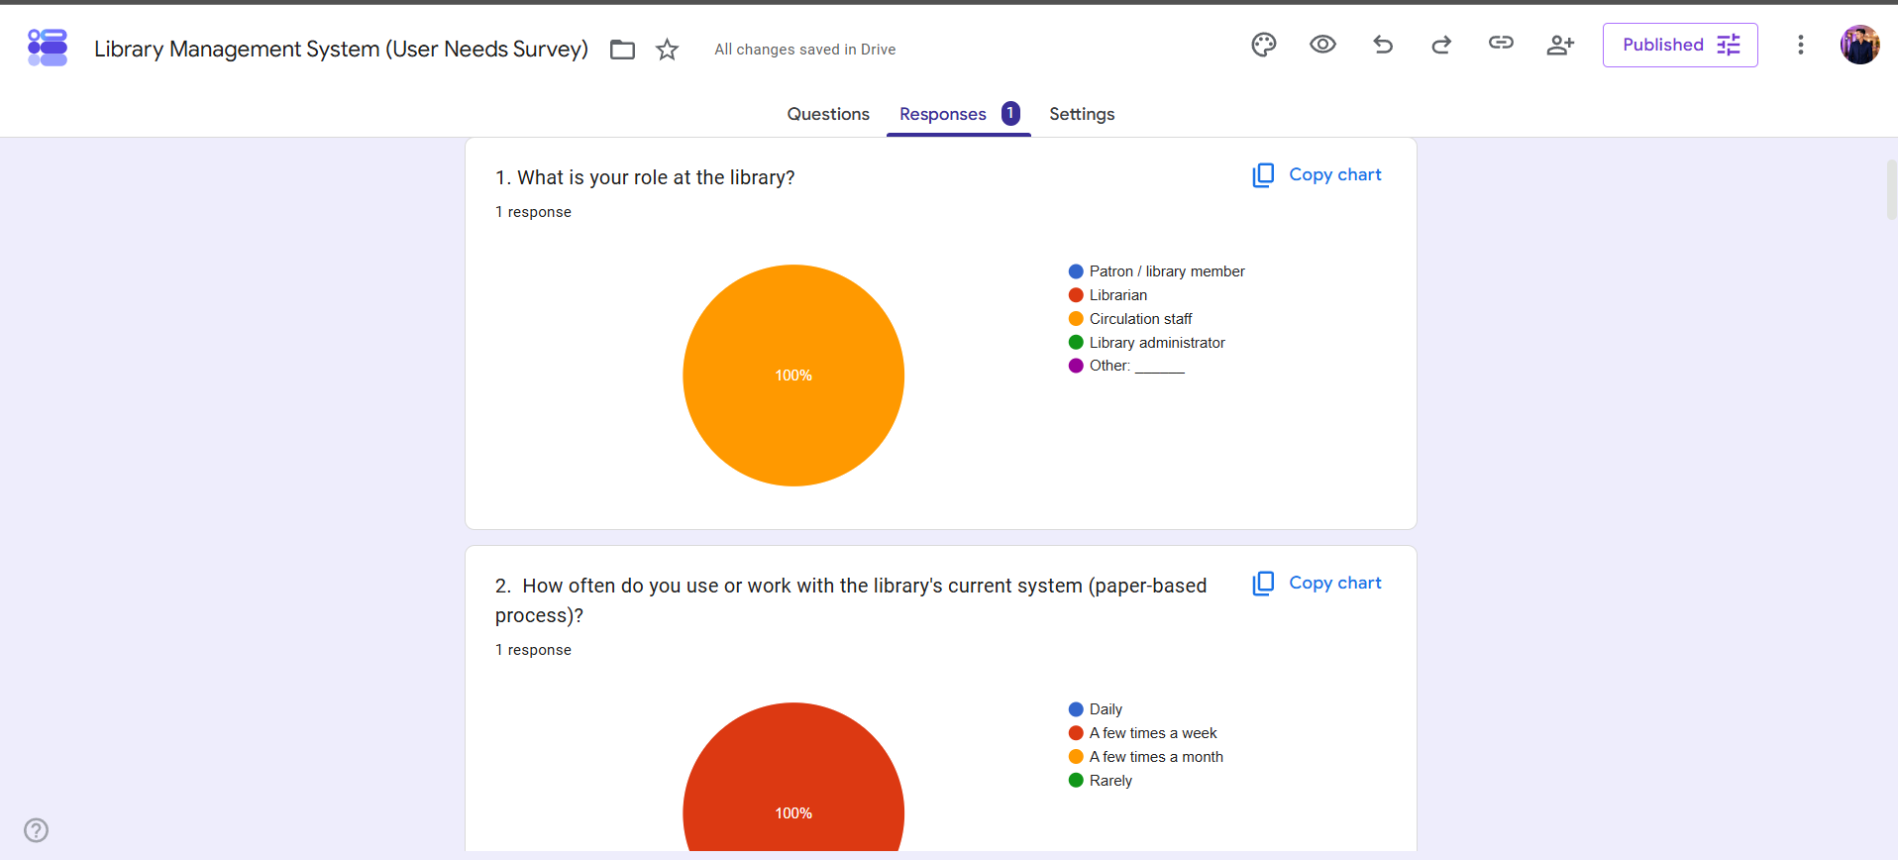
Figure 8
Final or Reply of the filled form

References
IEEE Computer Society. (1998). IEEE recommended practice for software requirements specifications (IEEE Std 830-1998). Institute of Electrical and Electronics Engineers.
Kotonya, G., & Sommerville, I. (1998). Requirements engineering: Processes and techniques. John Wiley & Sons.
Sommerville, I. (2016). Software engineering (10th ed.). Pearson Education.
Wiegers, K., & Beatty, J. (2013). Software requirements (3rd ed.). Microsoft Press.

